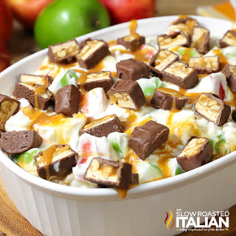
Snickers Caramel Apple Cheesecake Salad
Prep time/Total time 15 min
8 Servings
Ingredients
(2) 8 oz packages cream cheese
1 cup French vanilla coffee creamer
4 medium apples
20 bite-size Snickers candy bars (or 3 king size)
¼ cup caramel sauce
Directions
- Core and cut apples into bite size pieces and set aside. Remove skin if desired.
- Microwave cream cheese for 20 seconds to soften.
- In a medium tall bowl, using an electric mixer, whip cream cheese until it becomes smooth. It may bind up in the beaters but continue as is and it will loosen up.
- With the mixer running slowly, add creamer to the cream cheese approximately a tablespoon at a time (otherwise it will become lumpy). Mix until it becomes a smooth mixture and all the creamer has combined into the cream cheese. Continue to whip until smooth, light and fluffy, about 2 minutes.
- Add apples to the cheesecake mixture ensuring they are coated completely to help prevent browning.
- Cut snickers into bite size pieces and sprinkle on salad. Drizzle with caramel sauce.
- Serve immediately or chill until ready to serve.

Notes
To make ahead of time, prepare cheesecake mixture and refrigerate in a bowl. Mix all the fruit in a large bowl and refrigerate. Before serving, drain any excess liquid from the fruit and then fold the cheesecake filling into the fruit.
You can substitute 1 cup heavy cream, ¼ cup powdered sugar and 2 teaspoons of vanilla extract for creamer.

